|  |
| --- |
| Close-up image showing the leaf-sides of two oversized books side-by-side on a bookshelf, with additional books in soft focus background |
| **Management of E-Business**  LJMU-7505-COMP-62666 |
| |  |  |  | | --- | --- | --- | | **IBRAHIM EMMANUEL SUCCESS** | 10/31/23 | Management of E-Business | |

**INTRODUCTION**

Since its founding in 2018, DesiWear, a respected player in the Pakistani traditional apparel retail industry, has grown significantly in the market. It is well-known for its commitment to providing unmatched customer care and safeguarding Pakistan's rich cultural heritage. DesiWear understands the need to grow and adjust as the retail industry changes and consumer tastes move more and more toward online shopping. An important step in the company's growth, the decision to open an online store in 2024 aims to enable a smooth transition from a physical storefront to a strong online presence.

This strategic move ensures that DesiWear's outstanding quality and cultural relevance in traditional Pakistani apparel are available to a global audience. It is motivated by the brand's dedication to excellence and a vision that surpasses regional limits. The brand is eager to launch a comprehensive online strategy concurrently with the creation of the online store prototype. This all-encompassing approach seeks to incorporate essential components such as Search Engine Optimization (SEO) and social media integration in order to enhance online presence, stimulate consumer interaction, and give an exceptional user experience that is comparable to the caliber of services offered in their physical business.

The proposed solution to these problems is summarized in this study, which also outlines the innovative process that went into developing the prototype for the online fashion store. It also describes the strategy plan intended to meet the impending difficulties of moving into the digital realm while maintaining DesiWear's ideals of cultural sensitivity and first-rate customer care. A distinctive online shopping experience that appeals to DesiWear's discerning customer base is assured by the combination of a user-centric design, cutting-edge marketing techniques, and e-commerce best practices.

**ONLINE FASHION STORE PROTOTYPE**

The online fashion store prototype by DesiWear is the perfect example of how digital innovation and cultural legacy can coexist. It has been painstakingly designed to convert the rich character of traditional Pakistani apparel into a captivating online experience. The design approach presents a user-centric interface that encapsulates the appeal of intricate designs and bright textures typical with Pakistan's heritage, harmonizing the brand's offerings' visual beauty and cultural importance. The prototype aims to take consumers on a personalized trip by telling stories of cultural significance behind each clothing and providing an enjoyable purchasing experience, all through a simple and visually appealing structure.

The prototype, which prioritizes accessibility and user-friendliness, is designed to be adaptable across a range of devices by utilizing a responsive framework. In order to create an immersive experience that echoes the authenticity and richness of DesiWear's physical store and translates its cultural past into the digital sphere, high-resolution images and a carefully chosen color palette are used. The strategy places a strong emphasis on ease of use and accessibility, making sure that clients can always access the newest collections, special offers, and cultural insights. This encourages consumer loyalty and storytelling within the online marketplace.

DesiWear's online fashion store concept, which aims to connect with customers as an extension of the in-person retail experience, is essentially a digital representation of the brand's principles. The design concept combines storytelling, practical convenience, and cultural celebration to provide an engaging platform that honors the brand's heritage and appeals to a worldwide audience looking for an immersive and real experience with traditional Pakistani clothing.

WIREFRAMES AND DESCRIPTIONS OF DESIGN CHOICES

* **Homepage**

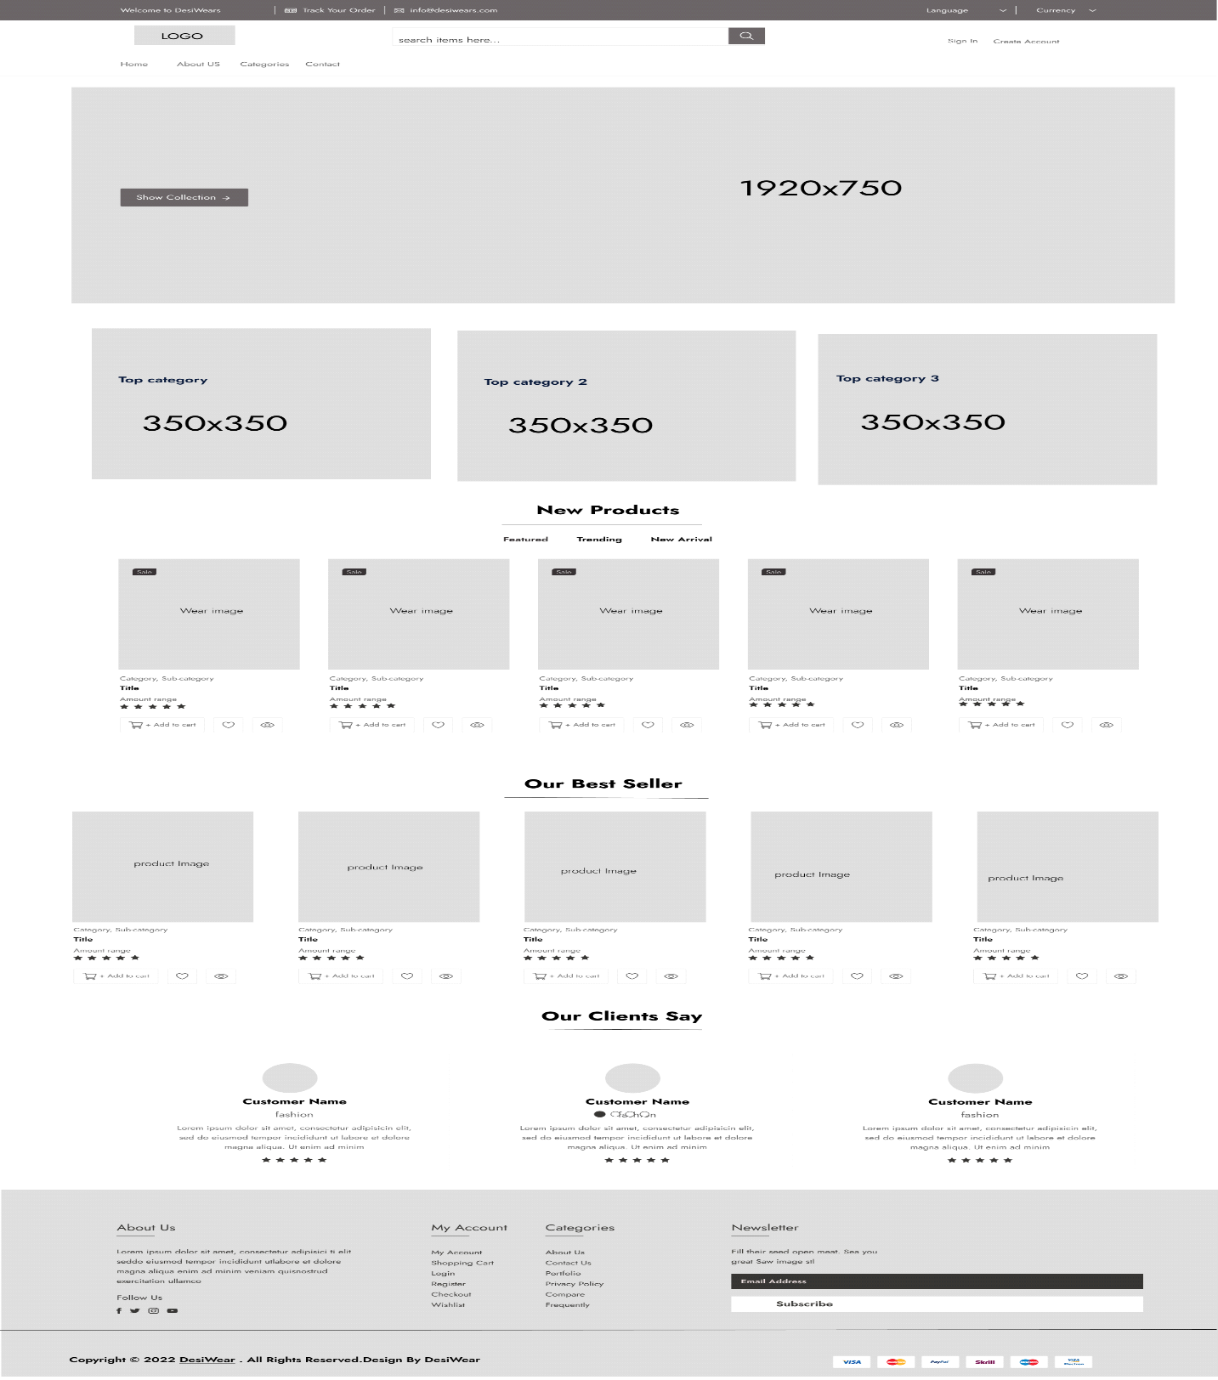

The wireframe for the homepage shows a clear, friendly interface with a hero banner showing DesiWear's iconic line. To aid with simple navigation. Users are encouraged to explore more by the layout, which highlights fine garment details and high-resolution photos.

Design decisions: The usage of a carousel hero banner tells an interesting story visually, and the placement of call-to-action buttons encourages users to explore the site right away. By maintaining an uncluttered interface, the minimalist design approach encourages user involvement and facilitates ease of navigation.

* **Product listing page**

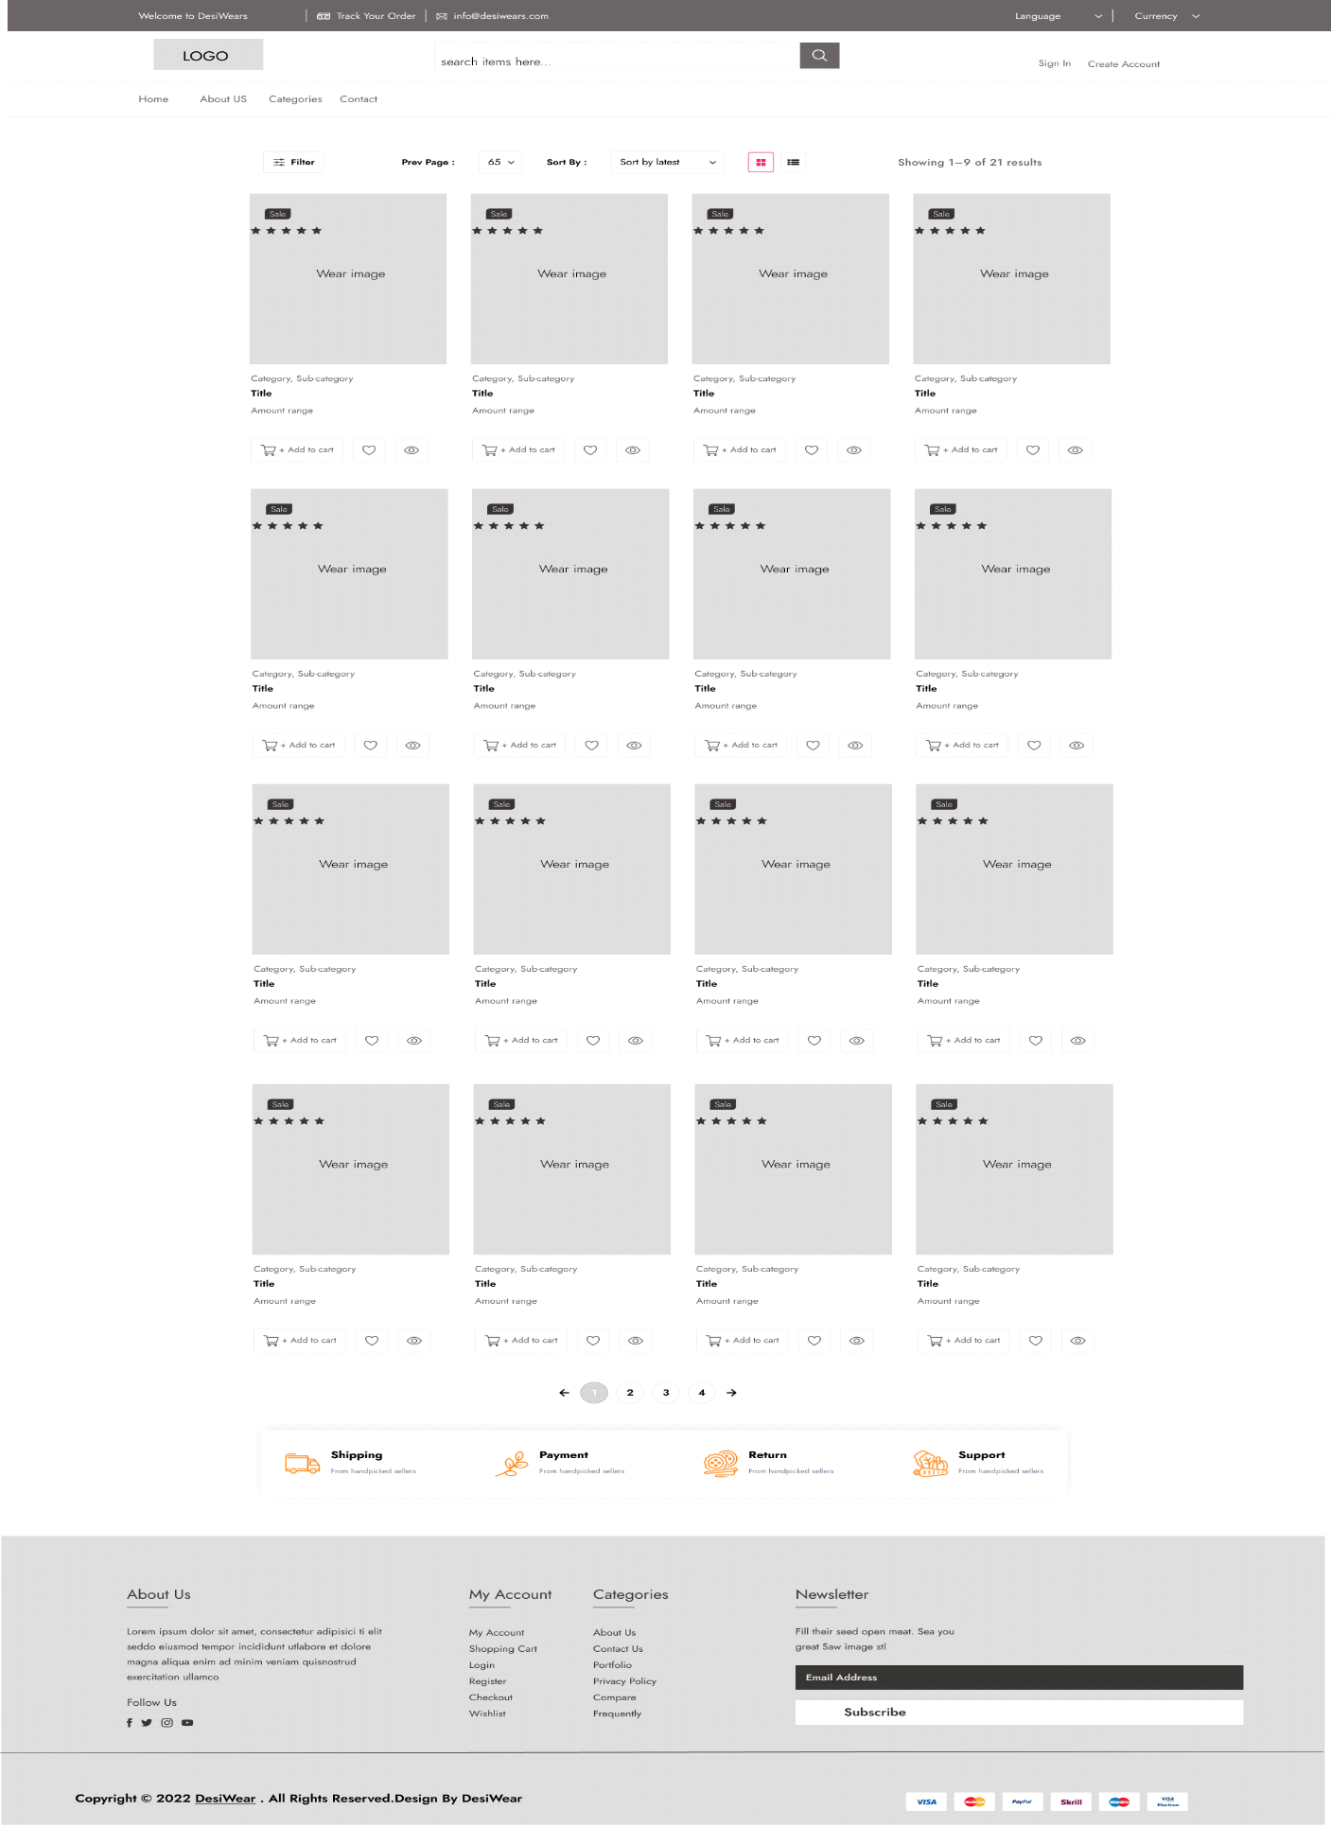

The product page wireframe is a well-organized design that features distinct product photos, thorough descriptions, and customizable sizes. Customers can concentrate on the fine features of each clothing, ensuring a thorough comprehension of the product, thanks to the display's emphasis on simplicity and clean design.

Design Decisions: By purposefully emphasizing product pictures, each item may be examined in greater detail. A streamlined structure keeps the shopping experience distraction-free, and the inclusion of succinct and comprehensive explanations guarantees that customers have the information they need.

* **Checkout page:**

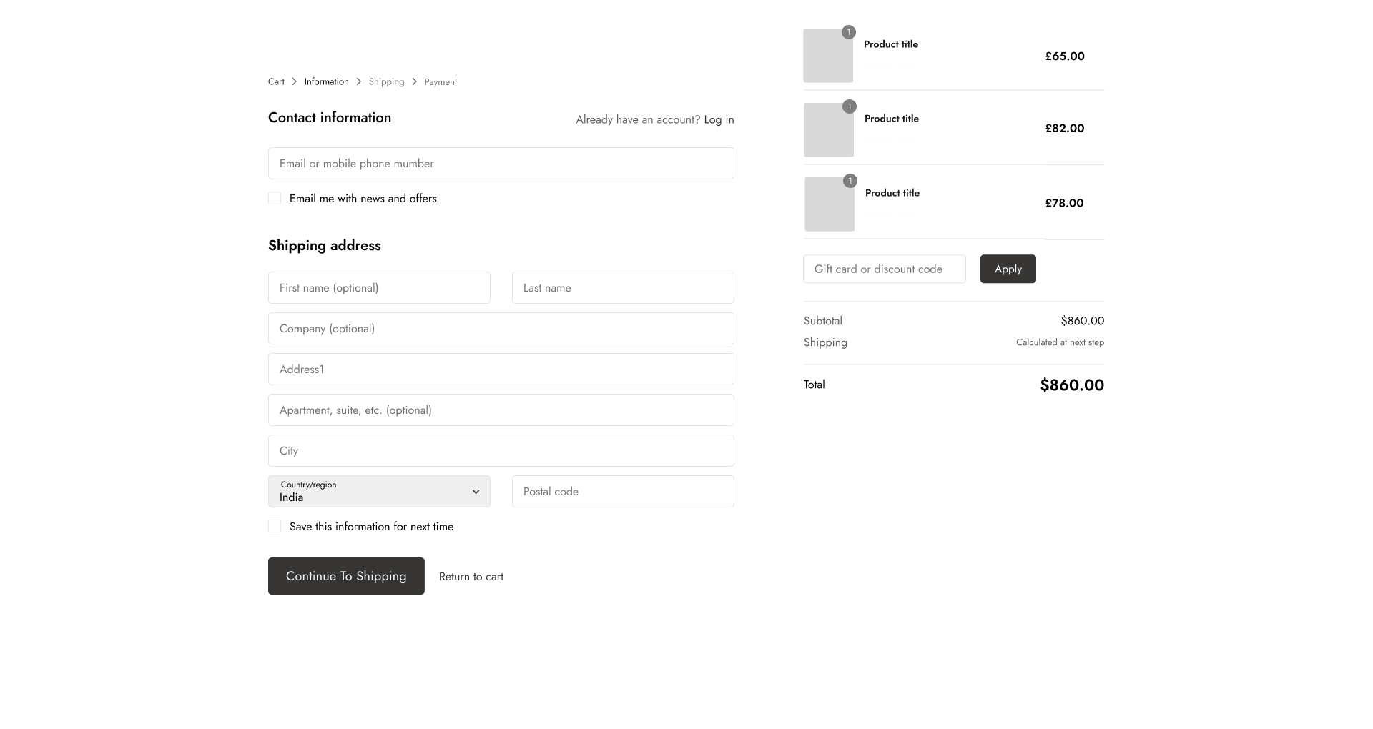

The wireframe for the checkout page presents a layout that is both user-friendly and streamlined. From cart inspection to payment confirmation, it shows a step-by-step evolution that guarantees a smooth and safe transaction process.

Design decisions: The checkout process is streamlined by the design, which emphasizes a thorough but minimalist approach. Utilizing progress bars and visual cues to guide consumers through transactions while preserving ease of use and trust lowers ambiguity.

* **Product details page**

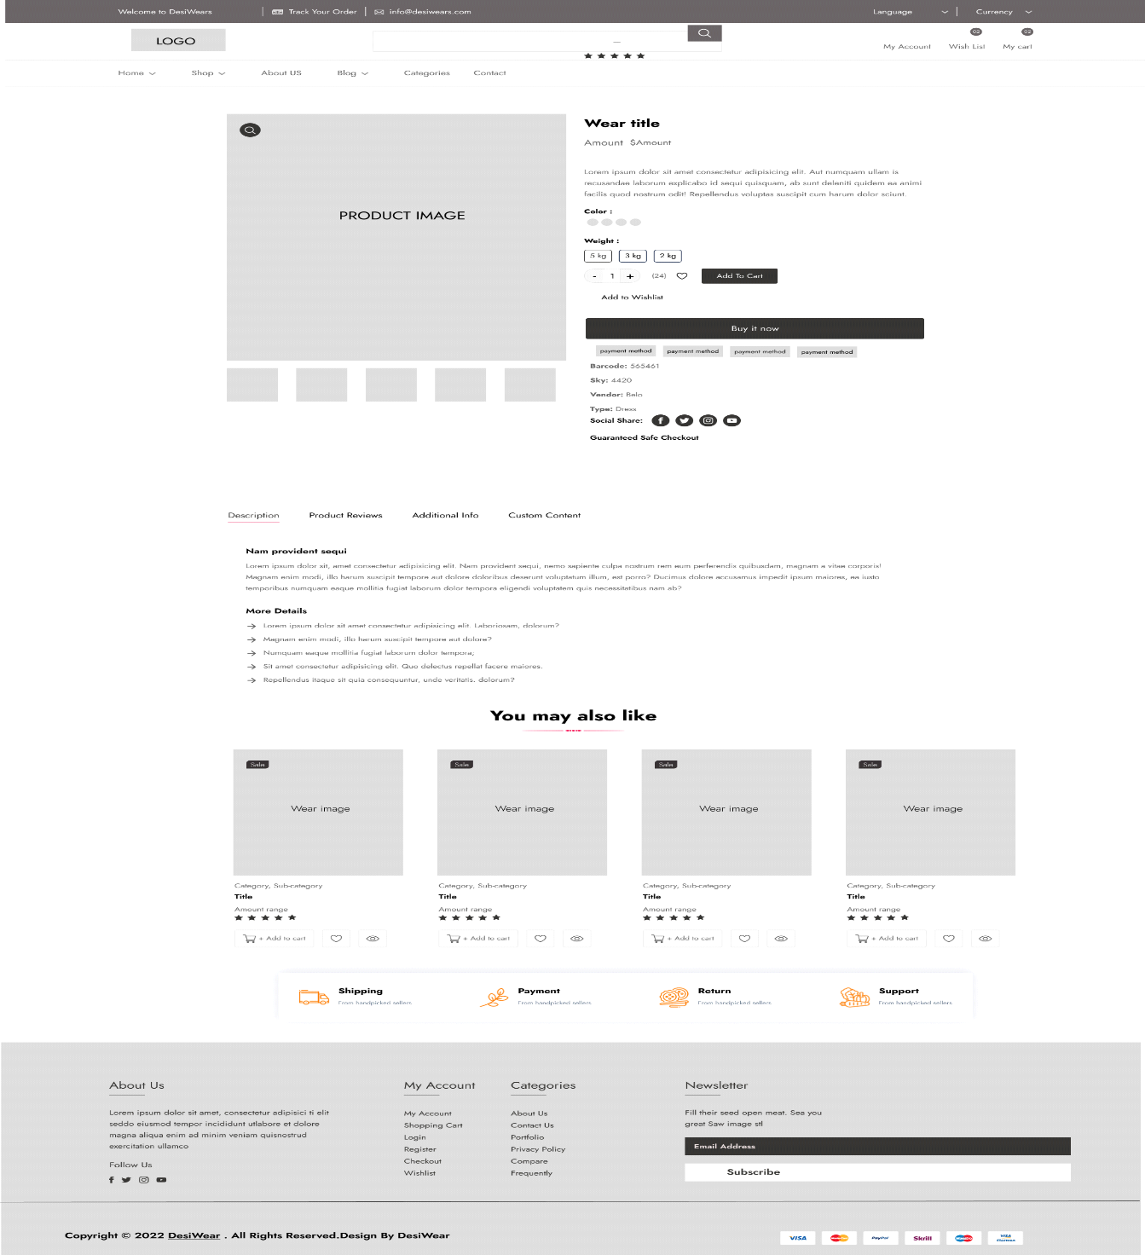

An essential part of the interface for the online fashion store is the wireframe for the product detail page. It provides a thorough, well-organized, and complete display of every product item. It displays particular clothing photos from several perspectives, giving buyers a deeper look at the material, style, and fine details. The wireframe includes a section for a thorough product description, including fabric kind, sizing, care instructions, and any other pertinent details, beneath the images. In order to provide a comprehensive and educational buying experience, it also includes user reviews and a section with similar or suggested items.

Design Choices: In order to guarantee that consumers fully comprehend the goods being displayed, the wireframe design places a strong emphasis on precision and clarity. Customers may examine the items in more detail and enjoy their finer details thanks to high-resolution pictures captured from various angles. The goal of including a thorough product description is to provide buyers all the information they need to make educated purchases. Customer evaluations also provide social proof and help create trust, and the related items section improves the buying experience by recommending related or complimentary products, which encourages more investigation and may result in add-on sales.

* **Shopping cart**

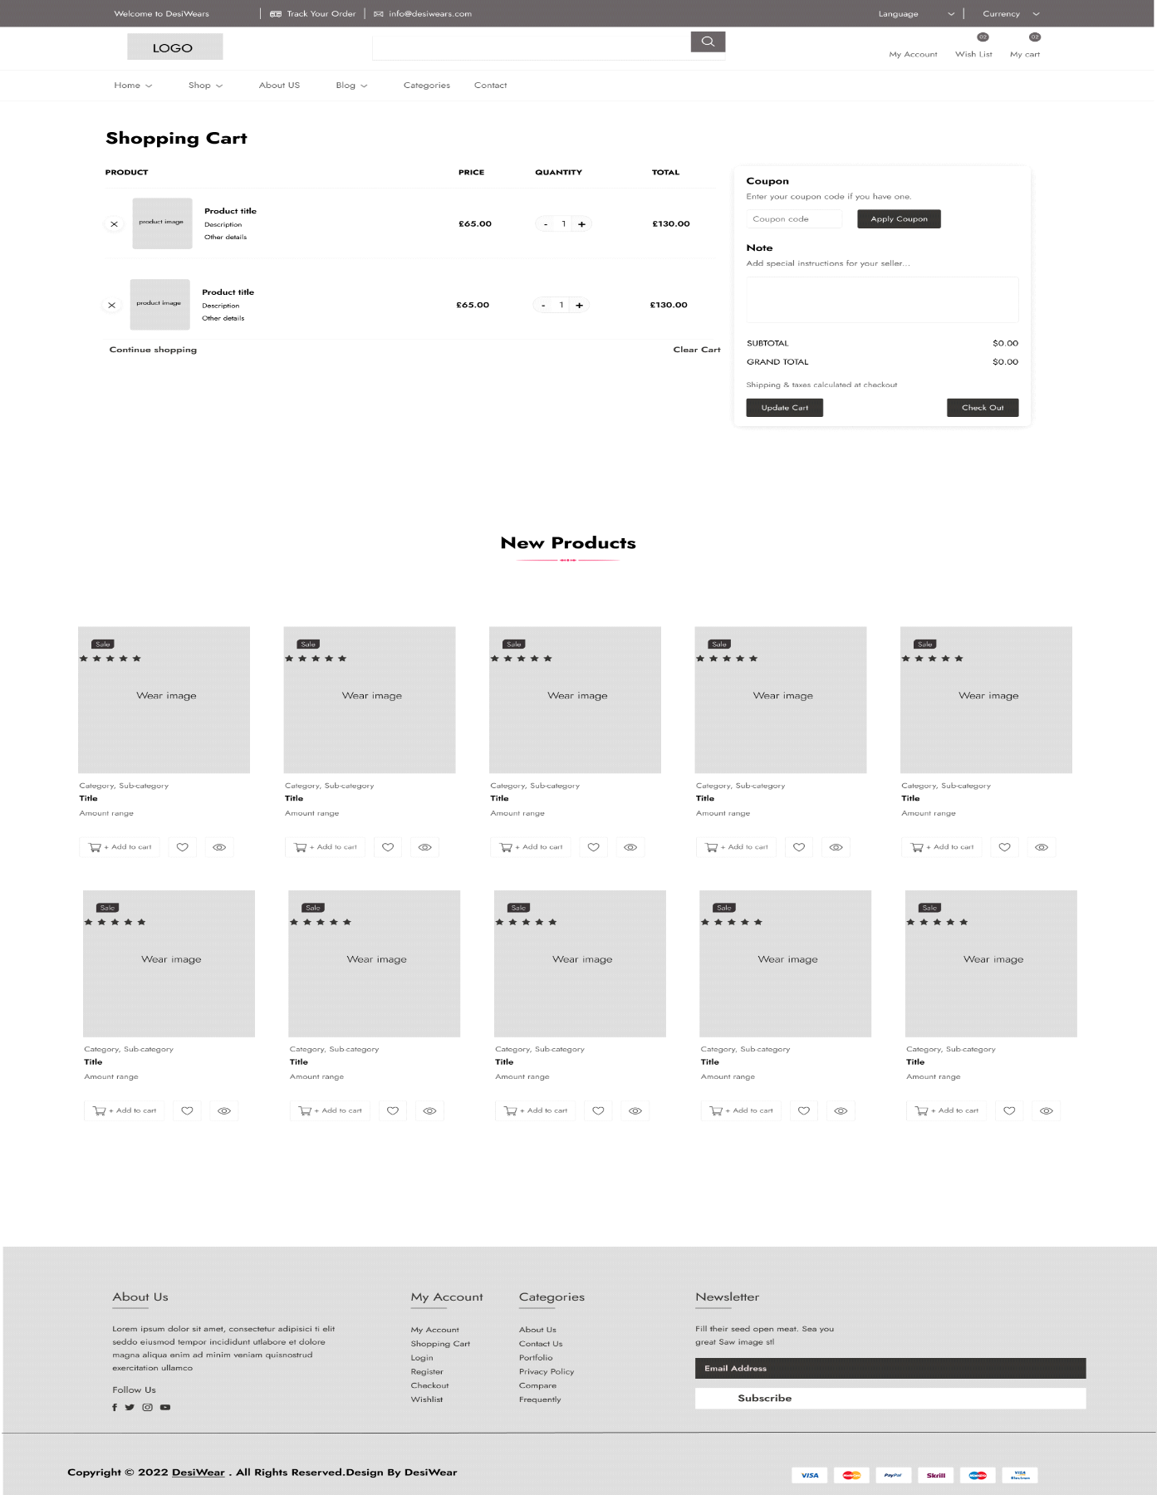

A crucial point in the consumer journey is represented by the wireframe of the shopping cart page, which gathers the chosen products for inspection and eventual purchase. This wireframe presents an overview of the products that were chosen for purchase, with details about each product, including its individual image, quantity, price, and subtotal. Customers can change quantities, delete goods, or proceed with their shopping with ease because to its concise and well-organized overview of the products they have chosen. It also has a large "Proceed to Checkout" button that makes it easy for customers to finish their purchases.

Design Decisions: The goal of the wireframe design is to give a clear, succinct picture of the products that have been chosen for purchase. Customers can quickly examine their selections by seeing distinct images of each product they have selected, along with information about pricing and available quantities. The shopping process is made more flexible by including features that permit changing quantities or removing items. Furthermore, the "Proceed to Checkout" button's strategic placement encourages customers to proceed quickly through the purchasing process by facilitating a seamless transition to the final stage.

* **Basic Template website**

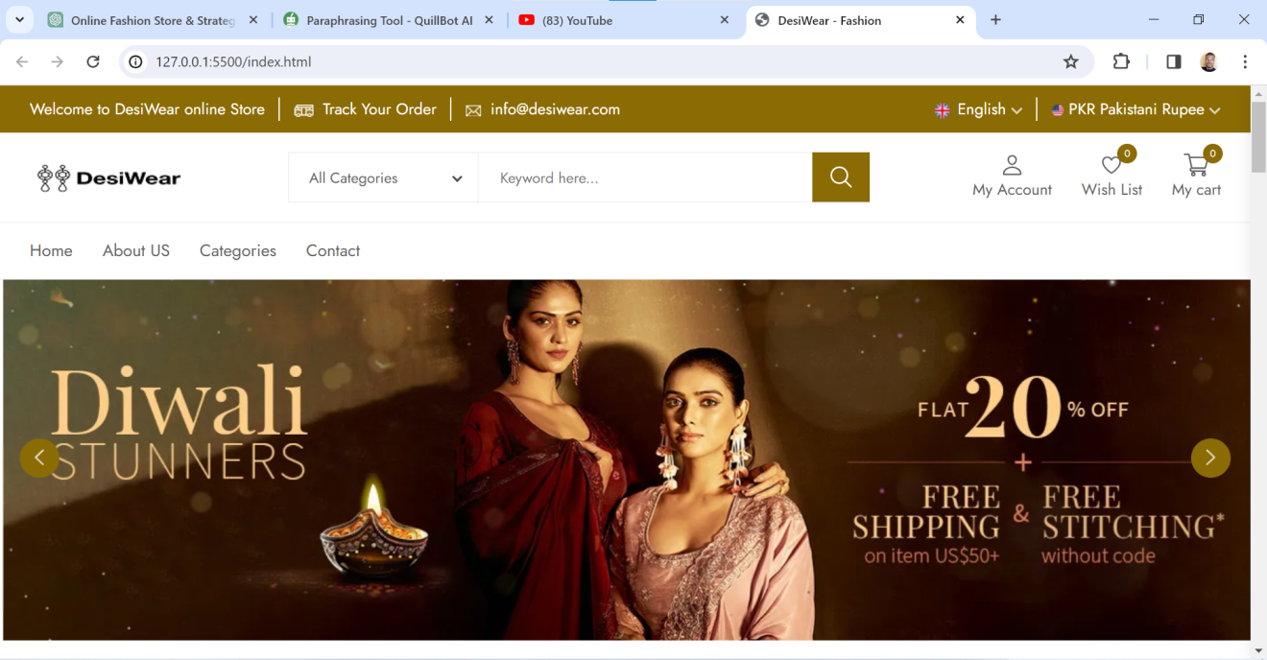

* **DesiWear Home page**

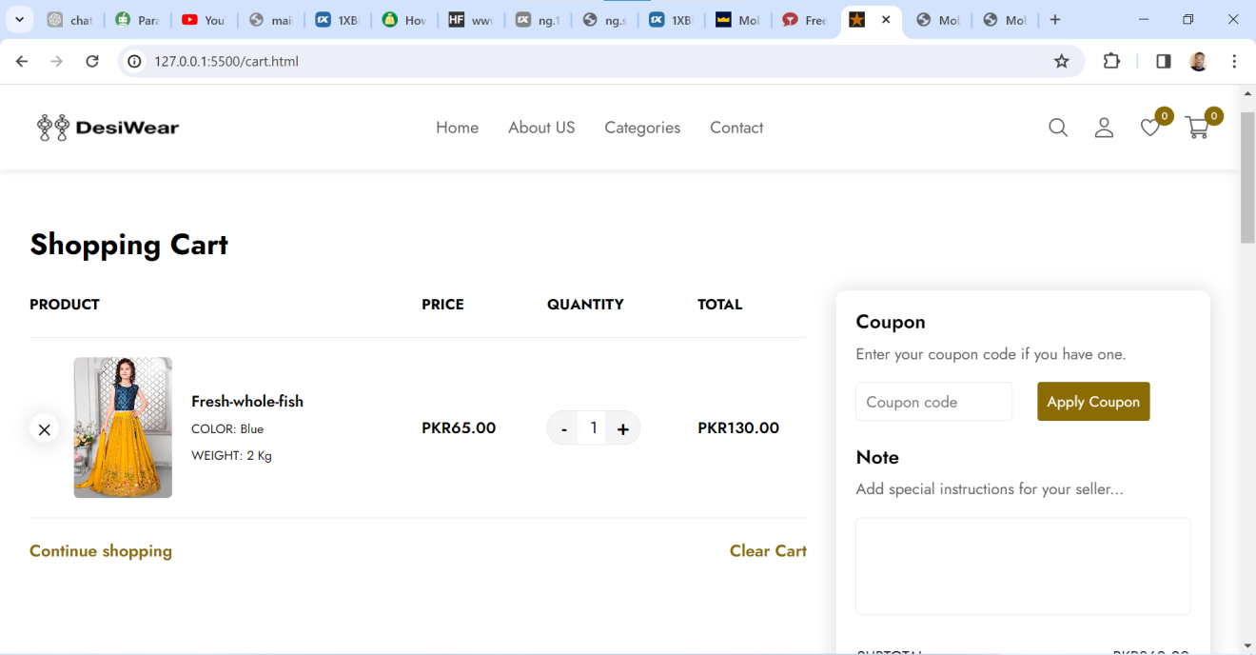

* **Shopping cart**

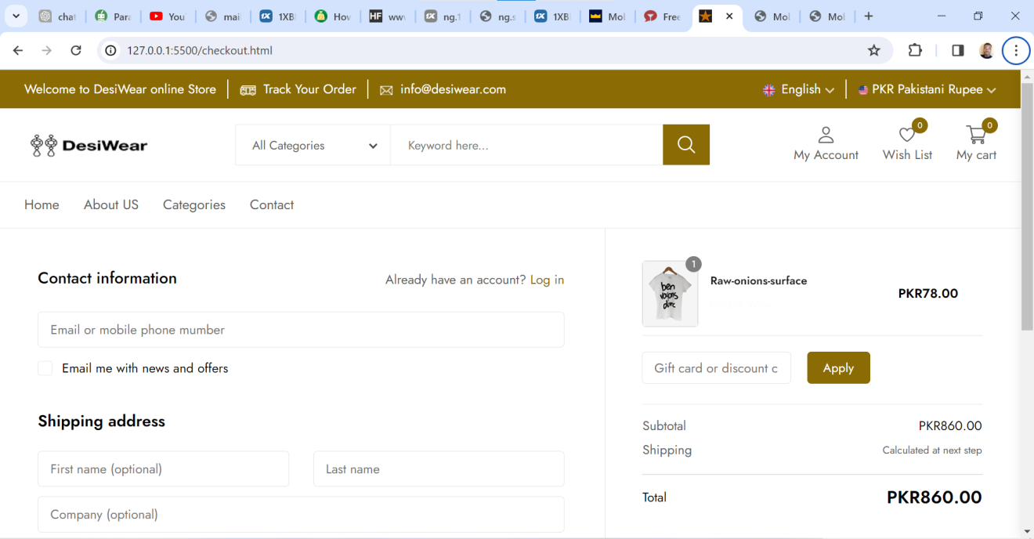

* **Checkout page**

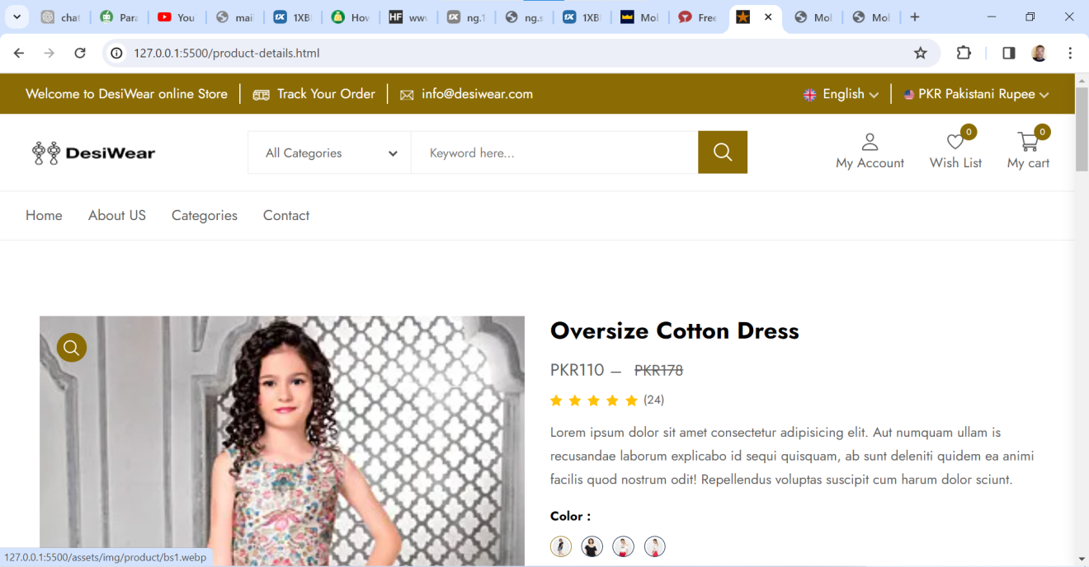

* **Product details page**

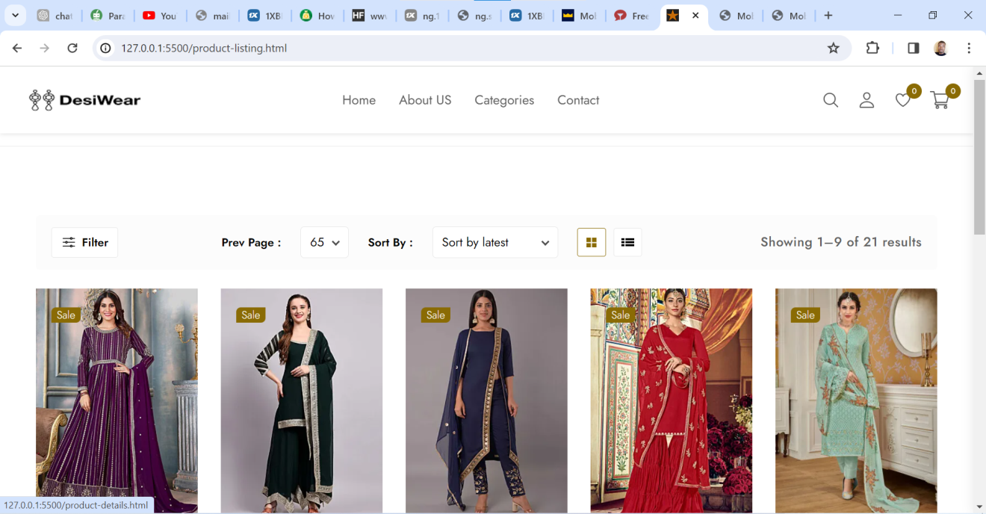

* **Product listing pages**

**EXPLANATION AND JUSTIFICATION FOR SOME DESIGN CHOICES**

1. Simple Navigation Menu: The navigation menu has been purposefully kept uncomplicated and uncluttered. Visitors will have a clear and uncomplicated browsing experience with a minimalist menu because it is less congested. It makes it possible for consumers to quickly locate the category they're looking for, which improves navigation and user satisfaction.

2. Hero Banner Highlighting the Newest Collection: The homepage has a big hero banner with colorful pictures of traditional Pakistani clothing on it, showcasing the newest collection. This eye-catching hero banner draws viewers in right away and invites them to keep exploring. It efficiently draws visitors into the DesiWear universe by acting as an instant presentation for the company's products and setting the tone for the website.

3. High-Resolution Product Photos with Zoom Capabilities: For a more in-depth look at fabric patterns and designs, each product page has high-resolution photos with zoom capabilities. In order to effectively showcase the fine features of traditional clothing and enable clients to closely inspect the craftsmanship and fabric quality, clear and comprehensive photos are essential. By improving the user experience, the zoom feature encourages confidence in judgments about what to buy.

4. Prominent "Proceed to Checkout" Button: The "Proceed to Checkout" button is placed prominently in the shopping cart. A prominent and simple-to-find button in the cart encourages customers to go quickly with the checkout process, which reduces abandoned carts and expedites the shopping experience.

**HOW WAS WEBSITE MADE MOBILE-FRIENDLY (RESPONSIVENESS)?**

DesiWear's website was carefully designed with mobile responsiveness as its top priority in order to provide a smooth and optimum user experience on a variety of devices. The website uses a fluid and adaptable grid style to dynamically resize its content to match various screen sizes, maintaining a unified and organized look across desktop, tablet, and smartphone platforms. The website responds intelligently to different screen widths with well-placed media queries, providing unique layouts for tiny, medium, and big displays. This guarantees that images and material are presented as best they can be on any device used to access them.

The design also prioritizes improving user engagement with touch-friendly elements and navigation. Touch gestures are supported with larger clickable areas and more space between components, which makes the website easier for visitors on touch-enabled devices to navigate. Faster loading speeds are a result of optimizing media files and photos for mobile devices, which improves user experience overall. In addition, the content hierarchy was carefully structured to ensure readability, making sure that paragraph lengths, line spacing, and font sizes were all modified for readability and accessibility on smaller displays. This strategy makes sure that visitors can easily read content without having to scroll or zoom in too much, resulting in a fun and intuitive mobile experience.

**ONLINE STRATEGY**

**Search Engine Optimization (SEO) Plan**:

DesiWear's online approach relies heavily on its SEO plan to increase online visibility, drive organic traffic, and make sure that potential shoppers can quickly find the brand's traditional clothing offers. Focusing on pertinent keywords that appeal to the target audience, the SEO plan aims to optimize the website's content and structure in a way that is consistent with user intent and search engine algorithms. By concentrating on particular keywords, SEO keywords density research examines how fashion websites are leveraging online communication to promote sustainability.

**Keyword Research and Optimization:**

**Keyword research:** Extensive keyword research is the cornerstone of any SEO strategy. This entails figuring out and evaluating the search terms that prospective buyers are probably going to use to find traditional Pakistani clothes. Keywords such as "hand-embroidered sarees," "ethnic shalwar kameez," and "Pakistani traditional clothing" are essential for comprehending the search behavior of customers.

**Content Optimization:** The website's articles, blog entries, and category pages all have their content carefully optimized with the chosen keywords. Every page is designed to offer interesting and educational content that improves user experience while also satisfying search engine algorithms.

**Technical Search Engine Optimization (SEO)**

**Site Speed and Mobile Optimization:** It's critical to make sure the website loads rapidly and is responsive to mobile devices. Search engines give priority to a great user experience, which is enhanced by mobile friendliness and a website that loads quickly.

**Schema Markup:** Rich snippets that improve visibility and click-through rates in search results are made possible by using schema markup to give structured data to search engines.

**Content Strategy**

**High-quality material:** DesiWear engages people and establishes itself as an industry authority by consistently producing high-quality and pertinent material, including as blog entries, style guides, and cultural narratives about traditional clothes.

**Internal and External Linking:** Building external backlinks through outreach, partnerships, and collaborations to boost domain authority and credibility, as well as implementing internal linking techniques to connect comparable content within the website, are two examples of linking tactics.

**Observation and Adjustment:**

Continuous tracking and evaluation of user activity, organic traffic, and keyword rankings on websites using tools like Google Analytics and Google Search Console.

To keep up with changing search engine algorithms and client trends, do regular SEO audits and make necessary improvements.

**SOCIAL MEDIA INTEGRATION**

The goal of DesiWear's website integration with social media is to give users a unified and engaging brand experience. The website will tell a dynamic and visually appealing story of Pakistani traditional attire through the thoughtful integration of Facebook, Instagram, and maybe Pinterest Visitors will be able to interact directly with DesiWear's most recent updates, product debuts, cultural insights, and behind-the-scenes stories through the seamless integration of social media widgets or integrated feeds, which will promote a greater connection and engagement with the brand's ethos.

Product pages on the website will have social media sharing icons that are simple to identify and use, enabling users to share their best discoveries and experiences with friends and family. Additionally, including social media advertising campaigns will be essential for focusing on and interacting with particular audience segments, driving backlinks to DesiWear's website, and promoting its collections. Highlighted partnerships with fashion experts and influencers will improve DesiWear's social media visibility and draw in more customers, establishing the company as a trailblazer in Pakistani traditional fashion.

DesiWear puts the needs of its customers first by making sure that they are communicated with on social media and responding to their questions, messages, and comments in a timely manner. The website seeks to create an engaging community space by promoting a dynamic ecosystem of user-generated content, shared experiences, and influencer collaborations. DesiWear wants to position itself as more than just a retailer of traditional clothing; it also wants to celebrate Pakistani heritage in the digital sphere. The website's social media integration is positioned to improve community involvement, brand visibility, and user interaction, creating a smooth and all-encompassing online experience for DesiWear's audience.

**CUSTOMER ENGAGEMENT AND RETENTION PLAN**

The consumer engagement approach places a strong emphasis on loyalty programs and tailored communications. DesiWear intends to launch focused email marketing campaigns that provide its clientele with tailored suggestions, styling advice, and exclusive deals. The company also plans to launch a tiered loyalty program that will honor social media activity, referrals, and repeat purchases. Within the first year, the goal is to boost customer engagement through email marketing by 20% and raise customer retention rates by 15%.

**METRICS FOR MEASURING ONLINE SUCCESS**

Several performance metrics will be used to gauge the effectiveness of these strategies:

1. **Organic Traffic**: Using efficient SEO techniques, there was a 30% increase in organic traffic in the first six months.

2. **Social Media Follower Growth**: Using interesting content, gain 50% more followers on Instagram and other platforms in the first year.

3. **Customer Engagement:** A 10% increase in website and email campaign customer contact is the goal.

4. **Conversion Rate**: During the first year, there will be a 15% increase in the percentage of website visitors who become customers.

These metrics serve as the benchmarks by which the effectiveness of the online strategy will be assessed; they show areas of progress as well as those that may require modification in order to support ongoing development and improvement.

**REFERENCES**:

Candeloro, D., 2019. Sustainability in the fashion brands websites: SEO keywords density analysis and consumers’ behavior. In Fashion Communication in the Digital Age: FACTUM 19 Fashion Communication Conference, Ascona, Switzerland, July 21-26, 2019 (pp. 188-197). Springer international Publishing.

Prudhomme, G. (2019) Software Services for E-Business. Ashland: Arcler Press. Available at: https://search.ebscohost.com/login.aspx?direct=true&db=nlebk&AN=2013923&site=ehost-live (Accessed: 31 October 2023)